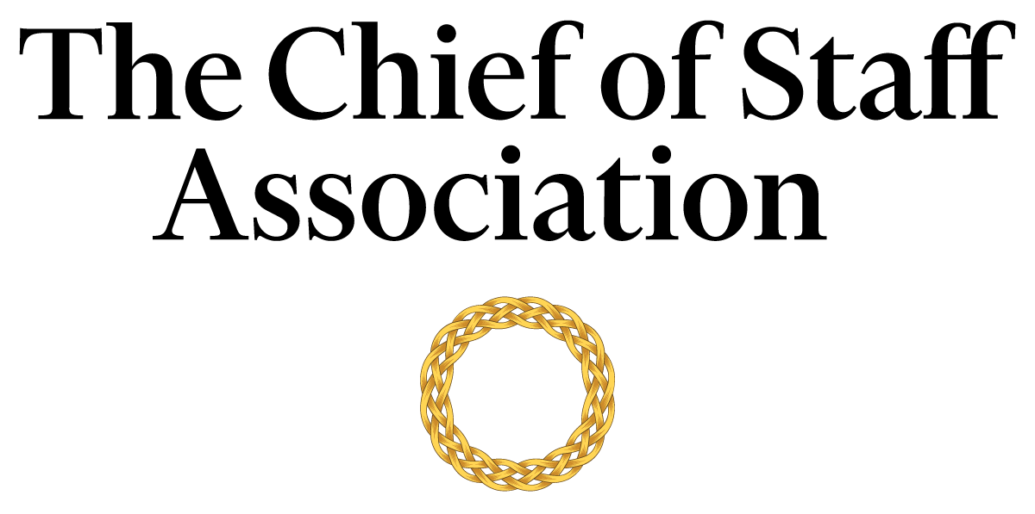

Chief of Staff - Office of the CEO - [Foundation]

[Foundation Mission Statement / Description]

Salary commensurate with qualification, education and experience.
We recommend membership in The Chief of Staff Association forms part of any remuneration package.

Position Information

Basic Function

The Chief of Staff (COS) serves as a member of [Foundation name’s] senior management team, with authority over a wide range of management and technical assignments. They are designated special projects that may be on-going and/or non-recurring in nature.

Dimensions
The COS works principally as an advisor to the CEO but also collaborates with members of the foundation’s core committee and executive team to maintain strategic alignment across the foundation’s departments. The COS supervises the work of foundation staff and consultants to varying degrees; including but not limited to the executive assistants, the office secretary, human resources and volunteers.

Nature and Scope
The COS is chiefly responsible for liaison, organization, and the execution of tasks that improve the CEO’s ability to deliver the foundation’s strategic agenda. The COS assists the CEO in driving internal stakeholder engagement with the Board of Trustees, the foundation family, executives, the endowment team, administrators, human resources, the office secretary, employees, and staff.
They also act as the primary contact for external parties including government officials, political and social consultants, auditors, legal representatives, representatives from financial institutions, representatives from other foundations, visitors, and the general public.

Principle Duties

The COS:
- Is the Principal Advisor to the CEO
- Manages the bi-directional flow of communication in and out of the CEO’s office to ensure consistent and responsive message delivery to key internal stakeholders, including other foundation executives, endowment managers, employees, volunteers, and staff.
- Assists in the planning, development and execution of policies and strategy consistent with the foundation’s objectives and governmental regulations.
- Prepares press releases in consultation with the communications team to ensure high-quality and streamlined messaging.
- Coordinates comprehensive projects across several different areas of the foundation including personnel/management reviews and special studies.
- Prepares the agenda for each senior executive meeting and provides a summary of discussions and action items resulting from each meeting to attendees, with appropriate follow-up. Occasionally attend such meetings in lieu of the CEO.
- Is responsible for directing the operations of the CEO’s Office while maintaining a constant interface with the core committee to ensure that key issues are proactively addressed and risks mitigated.
- Assists in the development of the foundation’s political strategy; including stakeholder mapping and engagement with Heads of State, diplomats, government officials, donors, and investors. This includes the development of the foundation’s lobbying effort in the relevant departments and high offices.
- Drives engagement and builds coalitions with other foundations and philanthropic bodies as required.
- Assists in the development and implementation of the foundation’s media strategy in consultation with internal stakeholders, and helps prepare the CEO for media representation.
- Supports the CEO in their public diplomacy efforts; including the development of media statements, op-eds, press releases and media interviews in consultation with the communications team.
- Supervises the position of the foundation’s endowment, and works with the endowment team and the CFO to prepare a quarterly briefing on endowment performance for the Board, the CEO, and the Foundation family.
- Represents the foundation and CEO (if required) at multilateral and bilateral conferences, including events and functions of the diplomatic corps and ambassadorial functions.
- Gathers and interprets data for use in executive decision-making. Handles data, communication and projects that are highly confidential with discretion.
- Provides leadership in the development and administration of Foundation-wide integrated plans and processes, including accreditation assessments and performance evaluation reviews.
- Builds and maintains mutually supportive relationships with all tiers of the foundation, including management, staff, external agencies, consultants and vendors. Works to remove barriers that hamper communication within the foundation.
- Coordinates and monitors assignments that must be accomplished in conjunction with other senior executives.
- Ensures the foundation is compliant with relevant local and federal laws applicable to foundations.
- Oversees travel resources for the CEO and compliance with travel policy.
- Oversees the CEO’s security requirements, including liaison with external security consultants.
- Performs ad-hoc tasks and special projects as required.

Core Competencies

The COS must demonstrate competency in and knowledge of:
- The principles, practices and methods of progressive leadership and staff level management, with a particular emphasis on directing programs, staff and cross-functional teams in an efficient and effective manner.
- Filtering and prioritizing information, particularly in relation to the management of the CEO’s time.
- Risk mitigation and crisis management practices and strategies.
- Organization and analysis, with the ability to formulate recommendations that improve strategic performance.
- Time-efficient project management completed to the highest ethical and professional standards.
- Oral and written communication skills; with a particular acumen for persuasive communication, mitigating and defusing conflict and stakeholder management.
- Prioritize work actions, including follow-up with accuracy and meticulous attention to detail.
- Effectively work under pressure and handle multiple priorities, tasks, demands and time-sensitive situations.
- Establish and maintain effective relations with the foundation’s internal and external stakeholders.
- Developing press releases and preparing materials for the media.
- Computer skills (Microsoft Office Suite); Excel and PowerPoint presentations.

Minimum Requirements
Master’s Degree in Business/Public Administration or related field, and [range] years of relevant experience and/or an equivalent combination of [range] years combined higher education/training and experience. Work with a previous foundation is an asset.

Note: This position description should not be construed to imply that these requirements are the exclusive standards for the position. Incumbents will follow any other instructions, and perform any other related duties, as may be required as directed by the foundation. [Foundation name] has the right to revise this position description at any time. This position description is not and should not be construed as a contract for employment.

