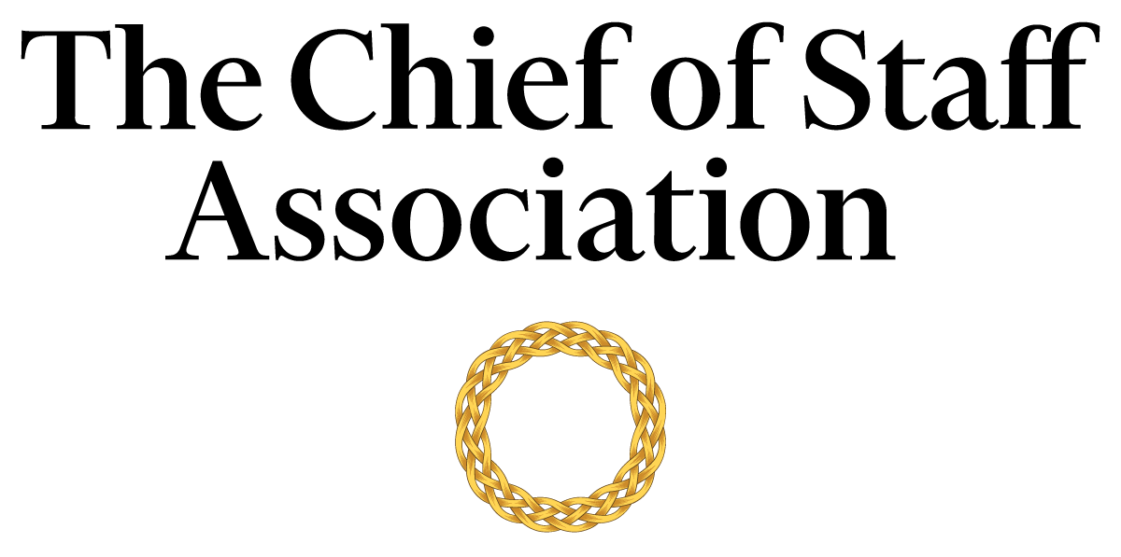

Chief of Staff - Office of the CEO
[Large Multinational Corporation]

[Multinational’s Mission Statement / Description]

Salary commensurate with qualification, education and experience.
We recommend membership in The Chief of Staff Association forms part of any remuneration package.

Position Information

Basic Function

The Chief of Staff (COS) serves as a member of [organization name’s] senior management team, with authority over a wide range of management and technical assignments within the organization. They will also be assigned special projects that may be on-going and/or non-recurring in nature.

Dimensions
The COS works principally as an advisor to the CEO but also collaborates with members of the executive committee to maintain strategic alignment. The COS supervises the work of office staff, professionals, consultants, executive assistants, office secretary, human resources, and the diary management team to varying degrees.

Nature and Scope
The COS is the principal source of liaison between internal stakeholders; namely the Board of Directors, the CEO, executives, administrators, human resources, investor relations team, legal counsel, risk management, media team, office secretary and staff. The COS is responsible for the organization and the execution of tasks that improve the CEO’s ability to deliver on the strategic agenda.
The COS is the primary contact for external parties including government officials, external consultants, auditors, legal representatives, union representatives, representatives from other financial institutions, financial counterparties, investment managers, regulatory authorities, the media, and visitors to the office.

Principle Duties

The COS:
- Is the Principal Advisor to the CEO.
- Is responsible for directing the operations of the CEO’s Office while maintaining a constant interface with the executive committee to ensure that key issues are proactively addressed.
- Manages the bi-directional flow of communication in and out of the CEO’s office to ensure consistent and responsive message and strategy delivery across business functions.
- Assists in the planning of policies and strategy consistent with company purpose and governmental regulations; ensuring different work functions maintain consistency with the company’s long-term agenda.
- Supervises key reports, including staff responsible for the production of financial metrics, risk report, and daily briefings for the CEO.
- Supervises the diary management team and executive assistant to ensure a well-run and efficient schedule for the CEO.
- Prepares press releases and works with [organization name]’s media team to provide high-quality inputs and direction to media organizations.
- Ensures that financial and risk metrics are kept up to date.
- Coordinates the CEO’s itinerary and travel schedule to ensure efficient use of their time.
- Supervises the drafting of market statements and presentations and ensures that the CEO is well-prepared for routine quarterly conference calls as well as other engagements with shareholders.
- Liaises with investor relations to keep abreast of the company’s financials, marketing message, and inputs from shareholders.
- Coordinates comprehensive projects across several different areas of the company including personnel/management reviews and special studies.
- Prepares an agenda for each senior executive meeting and provides a summary of discussions and action items resulting from each meeting to attendees, with appropriate follow-up. Occasionally attends such meetings in lieu of the CEO.
- Gathers and interprets data for use in executive decision-making. Handles data, communication and projects that are highly confidential with discretion.
- Provides leadership in the development and administration of firm-wide integrated plans and processes, including accreditation assessments and performance evaluation reviews.
- Builds and maintains effective stakeholder relationships with all tiers of the organization.
- Removes barriers that hamper inter-and intra-department communications and contributes to a positive and collegial culture that bolsters the firm’s esprit de corps and morale.
- Monitors assignments that must be accomplished in conjunction with other senior executives.
- Prepares reporting materials and/or reports for regulatory compliance.
- Oversees the CEO’s security requirements, including liaison with external security advisors.
- Prepares the CEO for Congressional testimony, hearings, and media briefings.
- Performs ad-hoc tasks and special projects as required.

Core Competencies

The COS must demonstrate competency in and knowledge of:
- The principles, practices and methods of progressive leadership and staff level management; with a particular emphasis on directing programs, staff and cross-functional teams in an efficient and effective manner.
- Filtering and prioritizing information, particularly in relation to the management of the CEO's time.
- Maintain effective internal and external stakeholder relationships; including stakeholder mapping and communications plans.
- Risk mitigation and crisis management practices and strategies.
- Oral and written communication skills; with a particular acumen for persuasive communication, mitigating and defusing conflict and stakeholder management.
- Time-efficient project management completed to the highest ethical and professional standards.
- Organization and analysis, with the ability to evaluate data and formulate recommendations that improve strategic performance.
- Prioritize work actions and follow-up with meticulous attention to detail.
- Work effectively under pressure, handle multiple priorities, tasks, demands and time-sensitive situations.
- Write press releases and prepare materials for the media.
- Prepare presentations and financial models at a high level.
- Knowledge of financial regulatory laws is an asset.

Minimum Requirements
Master’s Degree in Business Administration or related field, and [range] years of relevant experience and/or an equivalent combination of [range] years combined with higher education/training and experience. CFA is an asset.

Note: This position description should not be construed to imply that these requirements are the exclusive standards for the position. Incumbents will follow any other instructions, and perform any other related duties, as may be required as directed by the President of the University. The university has the right to revise this position description at any time. This position description is not and should not be construed as a contract for employment.

