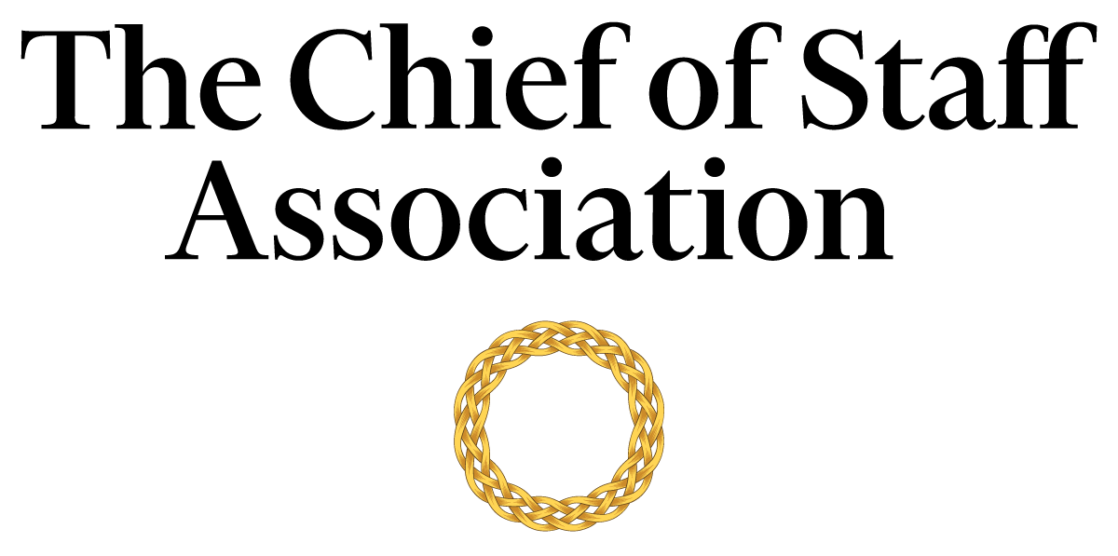

Chief of Staff - Office of the CEO [Startup]

[Startup Mission Statement / Description]

Salary commensurate with qualification, education and experience.
We recommend membership in The Chief of Staff Association forms part of any remuneration package.

Position Information

Basic Function

The Chief of Staff (COS) serves as a member of [startup name’s] senior management team, with authority over a wide range of management and technical assignments within the growing organization. They will also be assigned special projects that may be on-going and/or non-recurring in nature.

Dimensions
The COS works principally as an advisor to the CEO but also collaborates with members of the executive committee to maintain strategic alignment. The COS supervises the work of office staff to varying degrees; including but not limited to programmers, professionals, consultants, the executive assistant/office secretary, and human resource.

Nature and Scope
The COS is chiefly responsible for liaison between internal stakeholders; namely the Board of Directors, the CEO, other executives, HR, the office secretary, employees and staff. The COS is responsible for the organization and the execution of tasks that improve the CEO’s ability to deliver on the strategic agenda.
They also act as the primary contact for external parties including investors, consultants, legal representatives, representatives from financial institutions, other startups, regulators, and visitors to the office.

Principle Duties

The COS:
- Is the Principal Advisor to the CEO.
- Adopts a hands-on approach in the growing stage of the business; responsible for directing the operations of the CEO’s Office while maintaining constant interface with the core committee to ensure that key issues are proactively addressed.
- Manages the bi-directional flow of communication in and out of the CEO’s office to ensure consistent and responsive message and strategy delivery across business functions.
- Assists in the planning of policies and strategy consistent with company purpose and governmental regulations; ensuring different work functions maintain consistency with the company’s long-term agenda.
- Develops and implements a media strategy in consultation with internal stakeholders and prepares the CEO for media presence.
- Prepares press releases and works with [organization name]’s media team to provide high-quality inputs and direction to media organizations.
- Works independently to complete assignments involving the appropriate internal or external contacts.
- Coordinates comprehensive projects across several different areas of the company including personnel/management reviews and special studies.
- Prepares an agenda for each senior executive meeting and provides a summary of discussions and action items resulting from each meeting to attendees, with appropriate follow-up. Occasionally attend such meetings in lieu of the CEO.
- Attends industry conferences, with and without the CEO.
- Gathers and interprets data for use in executive decision-making. Handles data, communication and projects that are highly confidential with discretion.
- Builds and maintains mutually supportive relationships with all tiers of the organization.
- Performs ad-hoc tasks and special projects as required.

Core Competencies

The COS must demonstrate competency in and knowledge of:
- The principles, practices and methods of progressive leadership and staff level management; with a particular emphasis on directing programs, staff and cross-functional teams in an efficient and effective manner.
- Filtering and prioritizing information, particularly in relation to the management of the CEO's time.
- Maintain effective internal and external stakeholder relationships; including stakeholder mapping and communications plans.
- Time-efficient project management completed to the highest ethical and professional standards.
- Risk mitigation and crisis management practices and strategies.
- Oral and written communication skills; with a particular acumen for persuasive communication, mitigating and defusing conflict and stakeholder management.
- Organization and analysis, with the ability to evaluate data and formulate recommendations that improve strategic performance.
- Write press releases and prepare materials for the media.
- Prioritize work actions and follow-up with accuracy and meticulous attention to detail.
- Work effectively under pressure, handle multiple priorities, tasks, demands and time-sensitive situations.
- Establish and maintain effective and productive relations with the organization’s internal and external stakeholders.
- Working in a fast-paced environment; and commitment to completing tasks on time and to the highest ethical and professional standards.
- Computer skills (Microsoft Office Suite); Excel and PowerPoint presentations.
- A programming background is an asset.

Minimum Requirements
Master’s Degree in Business/Public Administration or related field, and [range] years of relevant experience and/or an equivalent combination of [range] years combined higher education/training and experience.
Experience with other startups is an asset.
Note: This position description should not be construed to imply that these requirements are the exclusive standards for the position. Incumbents will follow any other instructions, and perform any other related duties, as may be required as directed by the organization. [Organization Name] has the right to revise this position description at any time. This position description is not and should not be construed as a contract for employment.

