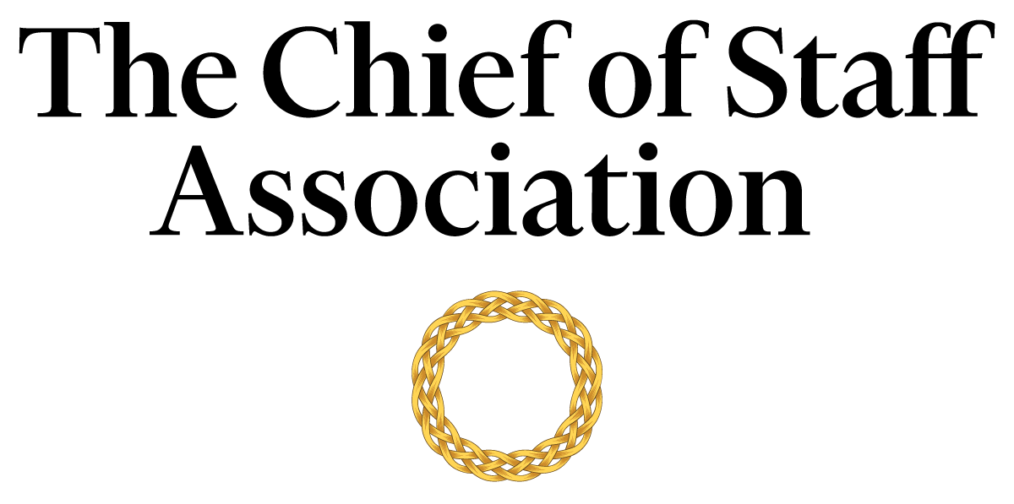

Chief of Staff - Office of a Cabinet Secretary -
[US Government Department]

[Department Description]

Salary commensurate with qualification, education and experience.
We recommend membership in The Chief of Staff Association forms part of any remuneration package.

Position Information

Basic Function

The Chief of Staff (COS) serves as a member of [Department name’s] senior management team, with authority over a wide range of management and technical assignments. They are designated special projects that may be on-going and/or non-recurring in nature.

Dimensions
The COS works principally as an advisor to the Cabinet Secretary but also collaborates with members of the department’s core committee and executive team to maintain strategic alignment. The COS supervises the work of departmental staff to varying degrees; including but not limited to consultants, executive assistants, office secretary, human resources, and the diary management team.

Nature and Scope
The COS is the principal source of liaison between internal stakeholders; namely the President, Senate-confirmed appointees, executives, administrators, human resources, office secretary and staff. The COS is responsible for the organization and the execution of tasks that improve the Cabinet Secretary’s ability to deliver on the strategic agenda.
They also act as the primary contact for external parties including government officials, consultants, auditors, legal representatives, union representatives, representatives from financial institutions, investment managers, representatives from other public bodies, and visitors to the office.

Principle Duties

The COS:
- Is the Principal Advisor to the Cabinet Secretary.
- Manages the bi-directional flow of communication in and out of the Cabinet Secretary’s office to ensure consistent and responsive message and strategy delivery across the office’s functions.
- Is responsible for directing the operations of the Secretary’s Office and serves as the Secretary’s liaison to various committees within the department.
- Assists in the planning of policies and strategy consistent with departmental objectives and governmental regulations; ensuring different work functions maintain consistency with the agenda,
- Develops and implements a media strategy in consultation with internal stakeholders to help prepare the Secretary for media appearances.
  - Prepares press releases in consultation with the communications team to ensure high-quality and streamlined messaging.
  - Prepares the Secretary for Congressional testimony, hearings, and media briefings.
- Coordinates comprehensive projects across several different areas of the department including personnel/management reviews and special studies.
- Prepares the agenda for each senior executive meeting and provides a summary of discussions and action items resulting from each meeting to attendees, with appropriate follow-up. Occasionally attend such meetings in lieu of the Cabinet Secretary.
- Gathers and interprets data for use in executive decision-making. Handles data, communication and projects that are highly confidential with discretion.
- Represents the department and Cabinet Secretary (if required) at multilateral and bilateral conferences, including events and functions of the diplomatic corps and ambassadorial functions.
- Provides leadership in the development and administration of department-wide integrated plans and processes, including accreditation assessments and performance evaluation reviews.
- Builds and maintains mutually supportive relationships with all tiers of the department, including management, staff, outside agencies, consultants and vendors.
- Prepares reporting materials and/or reports to Congress about compliance with relevant regulatory laws.
- Oversees the Secretary’s security requirements, including liaison with the security detail.
- Performs ad-hoc tasks and special projects as required.

Core Competencies

The COS must demonstrate competency in and knowledge of:
- The principles, practices and methods of progressive leadership and staff level management, with a particular emphasis on directing programs, staff and cross-functional teams in an efficient and effective manner.
- Maintain effective internal and external stakeholder relationships; including stakeholder mapping and communications plans.
- Risk mitigation and crisis management practices and strategies.
- Time-efficient project management completed to the highest ethical and professional standards.
- Filtering and prioritizing information, particularly in relation to the management of the Cabinet Secretary's time.
- Oral and written communication skills; with a particular acumen for persuasive communication, mitigating and defusing conflict and stakeholder management.
- Organization and analysis, with the ability to evaluate data and formulate recommendations that improve strategic performance.
- Prioritize work actions and follow-up with meticulous attention to detail and accuracy.
- Work effectively under pressure, handle multiple priorities, tasks, demands and time-sensitive situations.
- Write press releases and prepare materials for the media.
- Prepare congressional testimony.
- Prepare presentations and financial models at a high level.

Minimum Requirements
Master’s Degree in Business/Public Administration/Political Science or related field, and [range] years of relevant experience and/or an equivalent combination of [range] years combined higher education/training and experience.

Note: This position description should not be construed to imply that these requirements are the exclusive standards for the position. Incumbents will follow any other instructions, and perform any other related duties, as may be required as directed by the President of the University. The university has the right to revise this position description at any time. This position description is not and should not be construed as a contract for employment.

