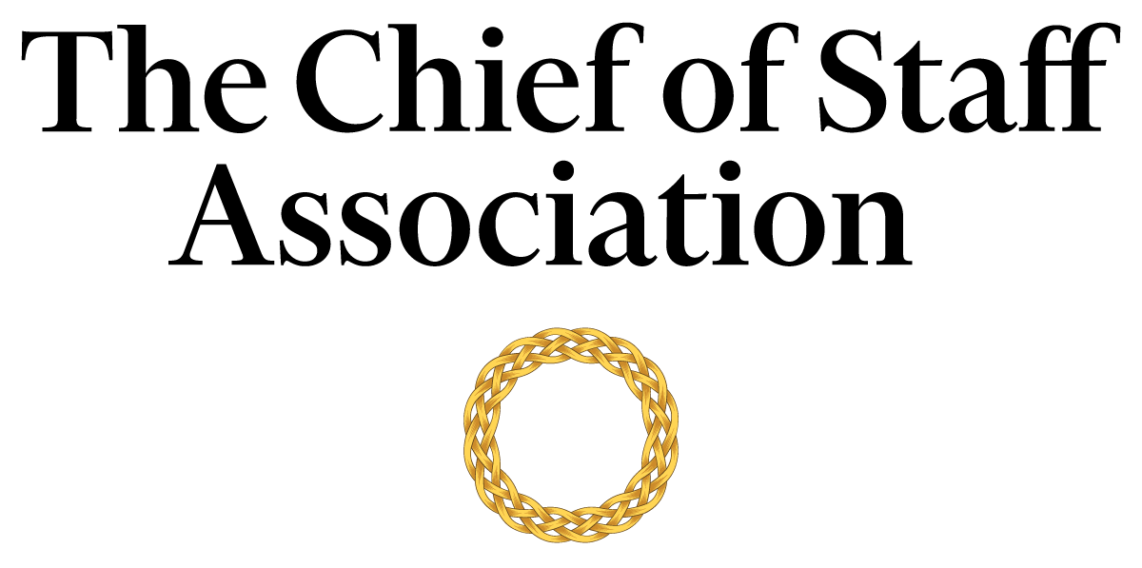

Chief of Staff - Office of the [Family Office]

[Family Office Mission Statement / Description]

Salary commensurate with qualification, education and experience.
We recommend membership in The Chief of Staff Association forms part of any remuneration package.

Position Information

Basic Function

The Chief of Staff (COS) serves as a member of the [family office name’s] senior management team, with authority over a wide range of management and technical assignments within the organization. They will also be assigned special projects that may be on-going and/or non-recurring in nature.

Dimensions
The COS works principally as an advisor to the family but also collaborates with members of the executive committee to maintain strategic alignment. The COS supervises the work of office staff, professionals, consultants, executive assistants, office secretary, human resources, and the scheduler to varying degrees.

Nature and Scope
The COS is the principal source of liaison between internal stakeholders; namely the Board of Directors, the family, executives, administrators, human resources, office secretary, employees and staff. The COS is responsible for the organization and the execution of tasks that improve the family’s ability to deliver on its strategic agenda.
The COS is the primary contact for external parties including tax and accounting experts, foundations and fundraisers, auditors, legal representatives, representatives from financial institutions, and investment managers, among others.

Principle Duties

The COS:
- Is the Principal Advisor to the family office.
- Is responsible for directing the operations of the family office while maintaining a constant interface with the core committee to ensure that key issues are proactively addressed.
- Manages the bi-directional flow of communication in and out of the family office to ensure consistent and responsive message and strategy delivery across business functions.
- Assists in the planning of policies and strategy consistent with the company purpose and governmental regulations; ensuring different work functions maintain consistency with the family office’s long-term agenda.
- Builds and maintains effective stakeholder relationships with all tiers of the organization.
- Oversees the scheduling and travel requirements of the family office. This includes responsibility for booking travel to the family’s comfort and satisfaction in compliance with budget restraints.
  - Ensures smooth passage through passport and immigration during international travel.
- Ensures financial control policies are implemented.
- Addresses family legal affairs in conjunction with legal counsel.
- Oversees the successful function of the philanthropy arm of the family office.
- Assists the family with media relations, including the issuance of press statements and preparation for media appearances.
- Gathers and interprets data for use in executive decision-making. Handles data, communication and projects that are highly confidential with discretion.
- Liaison with tax and accounting experts, as well as endowment and investment managers, to act in a fiduciary duty to the family.
- Assists with the schedule, budget, oversight, and execution of the family foundation’s event management itinerary and agenda.
- Prepares an agenda for each senior executive meeting and provides a summary of discussions and action items resulting from each meeting to attendees, with appropriate follow-up.
- Coordinate and monitor assignments that must be accomplished in conjunction with other senior executives.
- Oversees the family’s security requirements, including liaison with [Security Agency].
- Ensures the maintenance of the homes, yacht, jets, and other physical resources of the family.
- Performs ad-hoc tasks and special projects as required.

Core Competencies

The COS must demonstrate competency in and knowledge of:
- The principles, practices and methods of progressive leadership and staff level management, with a particular emphasis on directing programs, staff and cross-functional teams in an efficient and effective manner.
- Filtering and prioritizing information, particularly in relation to the management of the principal’s time.
- Risk mitigation and crisis management practices and strategies.
- Time-efficient project management completed to the highest ethical and professional standards.
- Maintain effective internal and external stakeholder relationships; including stakeholder mapping and communications plans.
- Oral and written communication skills; with a particular acumen for persuasive communication, mitigating and defusing conflict and stakeholder management.
- Organization and analysis, with the ability to evaluate data and formulate recommendations that improve strategic performance.
- Write press releases and prepare materials for the media.
- Prioritize work actions and follow-up with meticulous attention to detail.
- Work effectively under pressure, handle multiple priorities, tasks, demands and time-sensitive situations.
- Computer skills (Microsoft Office Suite); Excel and PowerPoint presentations.

Minimum Requirements
Master’s Degree in Business/Public Administration or related field, and [range] years of relevant experience and/or an equivalent combination of [range] years combined higher education/training and experience.
Previous experience with a family office is an asset.
Note: This position description should not be construed to imply that these requirements are the exclusive standards for the position. Incumbents will follow any other instructions, and perform any other related duties, as may be required as directed by the organization. [Organization Name] has the right to revise this position description at any time. This position description is not and should not be construed as a contract for employment.

