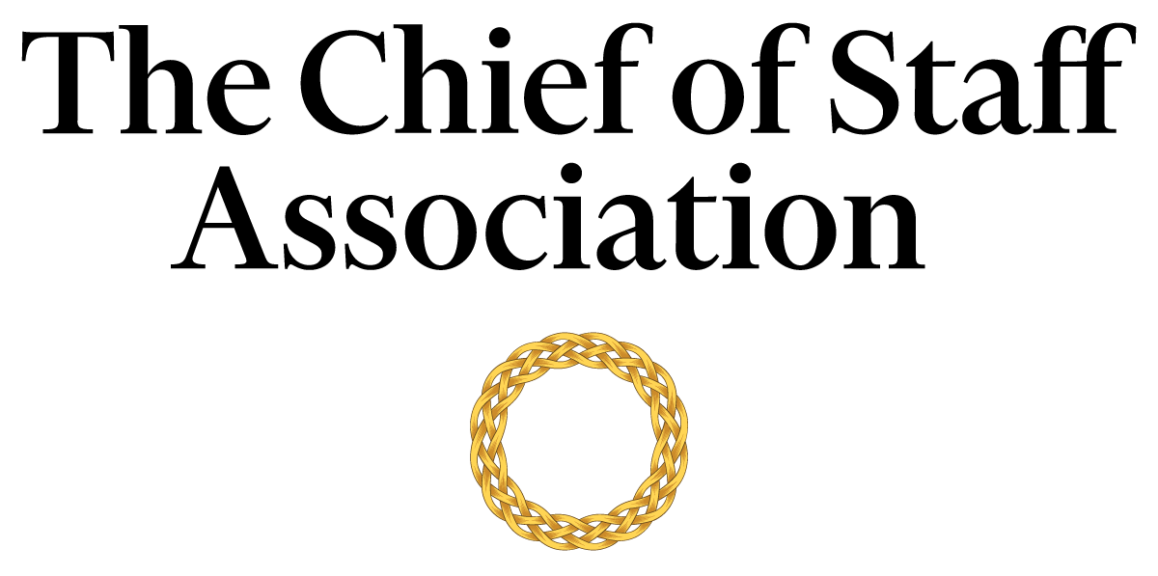

Chief of Staff - Office of the [Legislator]

[Description]

Salary commensurate with qualification, education and experience.
We recommend membership in The Chief of Staff Association forms part of any remuneration package.

Position Information

Basic Function

The Chief of Staff (COS) serves as a member of the [legislative office’s] senior management team, with authority over a wide range of management and technical assignments within the organization. They are designated special projects that may be on-going and/or non-recurring in nature.

Dimensions
The COS works principally as an advisor to the legislator but also collaborates with members of the office’s core committee and executive team to maintain strategic alignment. The COS supervises the work of team staff to varying degrees; including but not limited to consultants, executive assistants, office secretary, human resources, and the scheduler to varying degrees

Nature and Scope
The COS is chiefly responsible for liaison, organization, and the execution of tasks that improve the legislator’s ability to deliver the office’s strategic agenda. The COS assists the legislator in driving internal stakeholder engagement both stationed at the [Legislature] as well as in the core constituency of the [Legislator].
They also act as the primary contact for external parties including government officials, consultants, civil society representatives, committee chairs, members of industry, senior bureaucrats, representatives from other public bodies, and visitors to the [Legislature].

Principle Duties

The COS:
- Is the Principal Advisor to the Legislator.
- Is responsible for directing the operations of the [Legislator]’s Office while maintaining constant interface with the core committee to ensure that key issues are proactively addressed.
- Serves as the [Legislator]’s liaison to various committees within the [Legislature].
- Manages the bi-directional flow of communication in and out of the CEO’s office to ensure consistent and responsive message delivery to key internal stakeholders.
- Ensures both summary and detail research briefings on key legislative issues within the remit of the [Legislator]’s interest.
- Develops and implements a media strategy in consultation with the [Legislator] and the team, and helps prepare the [Legislator] for media presence.
- Prepares press releases and works with the [legislator]’s media and social media advisors to provide high-quality inputs to the media.
- Maintains consultations with prominent figures in the [legislator’]s core constituency, drawing upon their inputs to inform the work of the [legislator]’s Office.
- Prepares an agenda for each hearing, assembly, motion, and vote in the [Chamber], and provides a summary of discussions and action items resulting from each, with appropriate follow-up.
- Attends multilateral and bilateral conferences, with and without the legislator.
- Liaises with the [Legislator]’s political party and maintain requisite compliance with Campaign Finance Laws.
- Gathers and interprets data for use in executive decision-making. Handles data, communication and projects that are highly confidential with discretion.
- Builds and maintains mutually supportive relationships with all members of the [Legislature].
- Coordinates and monitors assignments that must be accomplished in conjunction with other senior executives.
- Represents the [Legislator] in events and functions of the diplomatic corps and ambassadorial functions
- Prepares reporting materials and/or reports to [Legislature] about compliance with relevant regulatory laws.
- Oversees the [Legislator]’s security requirements, including liaison with [Security Agency].
- Performs ad-hoc tasks and special projects as required.

Core Competencies

The COS must demonstrate competency in and knowledge of:
- The principles, practices and methods of progressive leadership and staff level management, with a particular emphasis on directing programs, staff and cross-functional teams in an efficient and effective manner.
- Filtering and prioritizing information, particularly in relation to the management of the legislator’s time.
- Risk mitigation and crisis management practices and strategies.
- Organization and analysis, with the ability to formulate recommendations that improve strategic performance.
- Time-efficient project management completed to the highest ethical and professional standards.
- Oral and written communication skills; with a particular acumen for persuasive communication, mitigating and defusing conflict and stakeholder management.
- Legislative processes and research.
- The [legislature’s] code of conduct.
- Campaign finance laws.
- Prioritize work actions and follow-up with meticulous attention to detail.
- Work effectively under pressure, handle multiple priorities, tasks, demands and time-sensitive situations.
- Establish and maintain effective relations with internal and external stakeholders.
- Commitment to completing tasks on time and to the highest ethical and professional standards.
- Computer skills (Microsoft Office Suite); Excel and PowerPoint presentations.
- Constitutional law is an asset.

Minimum Requirements
Master’s Degree in Business/Public Administration or related field, and [range] years of relevant experience and/or an equivalent combination of [range] years combined higher education/training and experience.

Note: This position description should not be construed to imply that these requirements are the exclusive standards for the position. Incumbents will follow any other instructions, and perform any other related duties, as may be required as directed by the organization. [Organization Name] has the right to revise this position description at any time. This position description is not and should not be construed as a contract for employment.

