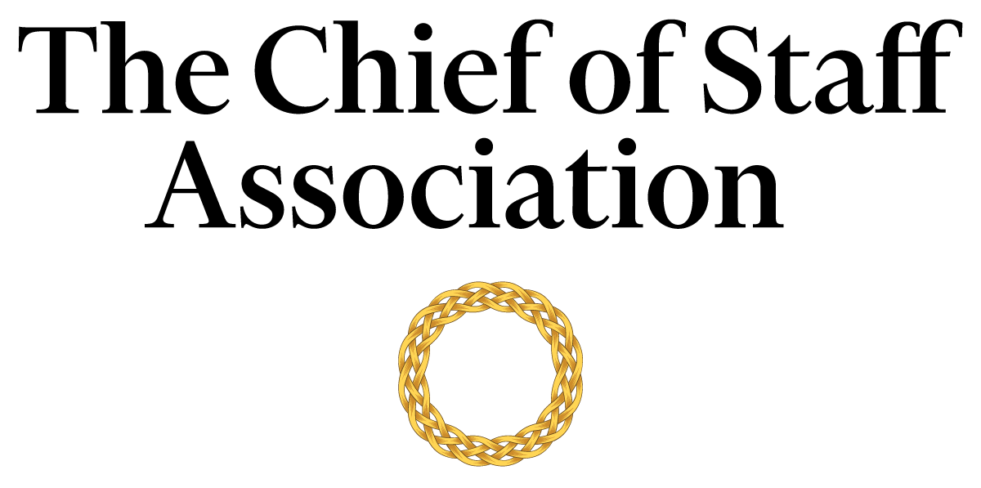

Chief of Staff - Office of the Minister [Ministry]

[Ministry Description]

Salary commensurate with qualification, education and experience.
We recommend membership in The Chief of Staff Association forms part of any remuneration package.

Position Information

Basic Function

The Chief of Staff (COS) serves as a member of the [Department’s name] senior management team, with authority over a wide range of management and technical assignments within the department. They will also be assigned special projects that may be on-going and/or non-recurring in nature.

Dimensions
The COS works principally as an advisor to the Minister but also collaborates with members of the executive committee to maintain strategic alignment. The COS supervises the work of office staff to varying degrees; including but not limited to consultants, executive assistants, office secretary and the human resources function.

Nature and Scope
The COS is the principal source of liaison between internal stakeholders; namely the Prime Minister, the PM’s appointees, Special Advisors, other Ministers, executives, administrators, human resources, office secretary and staff. The COS is responsible for the organization and the execution of tasks that improve the minister’s ability to deliver on the strategic agenda.
The COS is the primary contact for external parties including government officials, consultants, auditors, legal representatives, union representatives, representatives from financial institutions, investment managers, representatives from other public bodies, and visitors to the office.

Principle Duties

The COS:
- Is the Principal Advisor to the Minister.
- Manages the bi-directional flow of communication in and out of the Ministry to ensure consistent and responsive message and strategy delivery across departments.
- Is responsible for directing the operations of the Minister’s Office while maintaining a constant interface with the core department staff.
- Builds and maintains effective stakeholder relationships with all tiers of the department.
- Serves as the Minister’s liaison to other Ministries and departments.
- Develops and implements a media strategy in consultation with internal stakeholders and prepares the Minister for media appearances.
- Prepares press releases and works with the Ministry’s media team to provide high-quality inputs and direction to the media.
- Manages projects and assignments that require coordination of several different offices and/or areas of the department including personnel/management reviews, and special studies.
- Prepares an agenda for each senior executive meeting and provide a summary of discussions and action items resulting from each meeting to attendees, with appropriate follow-up. Occasionally attend such meetings in lieu of the Minister.
- Attends multilateral and bilateral conferences, with and without the Minister.
- Gathers and interprets data for use in executive decision-making. Handles data, communication and projects that are highly confidential with discretion.
- Provides leadership in the development and administration of integrated plans and processes, including performance evaluation reviews.
- Removes barriers that hamper communications.
- Prepares reporting materials and/or reports to Parliament about compliance with relevant regulatory laws.
- Readies domestic and international travel resources for the Minister and maintain compliance with relevant legislative oversight for use of resources.
- Oversees the Minister’s security requirements if required.
- Prepares the Minister for parliamentary inquiries, testimony, hearings, and media briefings.
- Performs ad-hoc tasks and special projects as required.

Core Competencies

The COS must possess and demonstrate competencies in:
- The principles, practices and methods of progressive leadership and staff level management, with a particular emphasis on directing programs, staff and cross-functional teams in an efficient and effective manner.
- Filtering and prioritizing information, particularly in relation to the management of the principal’s time.
- Risk mitigation and crisis management practices and strategies.
- Time-efficient project management completed to the highest ethical and professional standards.
- Maintain effective internal and external stakeholder relationships; including stakeholder mapping and communications plans.
- Oral and written communication skills; with a particular acumen for persuasive communication, mitigating and defusing conflict and stakeholder management.
- Organization and analysis, with the ability to evaluate data and formulate recommendations that improve strategic performance.
- Production of presentations and financial models at a high level.
- Parliamentary proceedings, protocols, and testimony processes.
- Writing press releases and preparing materials for the media.
- Prioritize work actions and follow-up with meticulous attention to detail and accuracy.
- Work effectively under pressure and handle multiple priorities simultaneously.
- Maintain effective and harmonious relations with the department’s stakeholders.

Minimum Requirements
Master’s Degree in Business/Public Administration/Political Science or related field, and [range] years of relevant experience and/or an equivalent combination of [range] years combined higher education/training and experience.

Note: This position description should not be construed to imply that these requirements are the exclusive standards for the position. Incumbents will follow any other instructions, and perform any other related duties, as may be required as directed by the President of the University. The university has the right to revise this position description at any time. This position description is not and should not be construed as a contract for employment.

[Compensation Section: The Chief of Staff Association would be pleased to advise you on the specifics of compensation for any COS position. Please email contact@csa.org to schedule a phone call with a CSA representative who would be pleased to assist you.]

