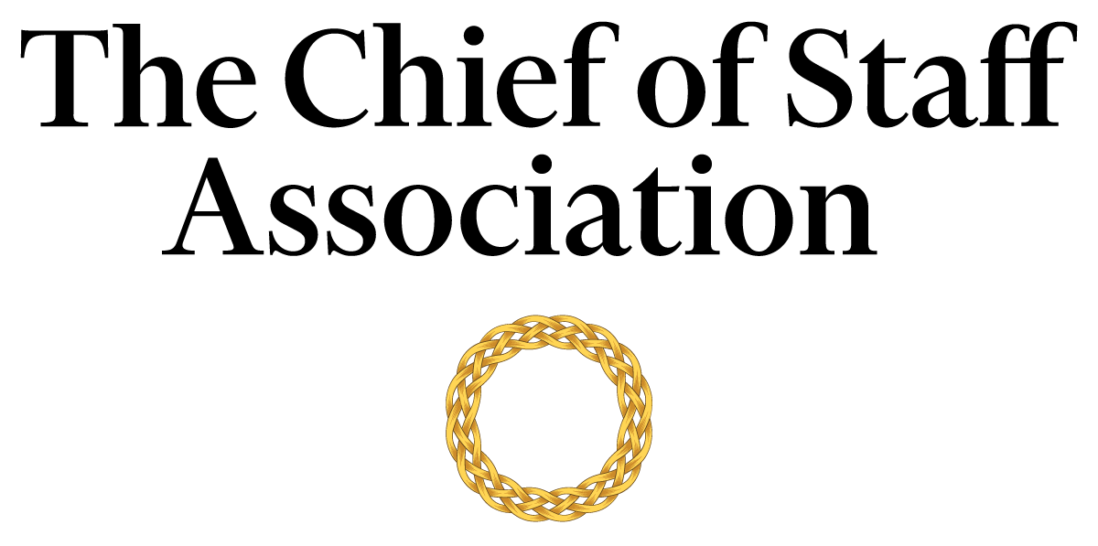

Chief of Staff - Office of the President
[Not-for-Profit]

[Organization Mission Statement / Description]

Salary commensurate with qualification, education and experience.
We recommend membership in The Chief of Staff Association forms part of any remuneration package.

Position Information

Basic Function

The Chief of Staff (COS) serves as a member of the [organization name’s] senior management team, with authority over a wide range of management and technical assignments within the organization. They will also be assigned special projects that may be on-going and/or non-recurring in nature.

Dimensions
The COS works principally as an advisor to the President but also collaborates with members of the executive committee to maintain strategic alignment. The COS supervises the work of office staff to varying degrees; including but not limited to consultants, executive assistants, office secretary, human resources, and the scheduler.

Nature and Scope
The COS is the principal source of liaison between internal stakeholders; namely the Board of Trustees, the President, administrators, human resources, office secretary, employees and staff. The COS is responsible for the organization and the execution of tasks that improve the President’s ability to deliver on its strategic agenda.
The COS is the primary contact for external parties including government officials, donors, consultants, field experts, auditors, legal representatives, academics, representatives from other not-for-profits, visitors, and the general public.

Principle Duties

The COS:
- Is the Principal Advisor to the President.
- Is responsible for directing the operations of the President’s Office while maintaining a constant interface with the core committee to ensure that key issues are proactively addressed.
- Serves as the President’s liaison to various committees within the organization.
- Manages the bi-directional flow of communication in and out of the President's Office to ensure consistent and responsive message delivery to key internal stakeholders.
- Works with event managers to design, organise and run donor-related events.
- Monitors the proceeds of the organization from all sources and prepares regular reports to detail those flows.
- Develops and implements a media strategy in consultation with internal stakeholders and prepares the President for media presence.
- Prepares press releases and works with [organization name]’s media consultants to provide high- quality inputs to the media.
- Coordinates some specific engagement activities with the President’s Office around specific strategic and operational matters.
- Manages donor relations and donor satisfaction.
- Prepares an agenda for each senior executive meeting and provides a summary of discussions and action items resulting from each meeting to attendees, with appropriate follow-up. Occasionally attend such meetings in lieu of the President.
- Attends multilateral and bilateral conferences, with and without the principal.
- Gathers and interprets data for use in executive decision-making. Handles data, communication and projects that are highly confidential with discretion.
- Builds and maintains effective stakeholder relationships with all tiers of the organization.
- Represents the President in events and functions of the diplomatic corps and ambassadorial functions
- Performs ad-hoc tasks and special projects as required.

Core Competencies

The COS must demonstrate competency in and knowledge of:
- The principles, practices and methods of progressive leadership and staff level management, with a particular emphasis on directing programs, staff and cross-functional teams in an efficient and effective manner.
- Filtering and prioritizing information, particularly in relation to the management of the principal’s time.
- Risk mitigation and crisis management practices and strategies.
- Time-efficient project management completed to the highest ethical and professional standards.
- Maintain effective internal and external stakeholder relationships; including stakeholder mapping and communications plans.
- Oral and written communication skills; with a particular acumen for persuasive communication, mitigating and defusing conflict and stakeholder management.
- Organization and analysis, with the ability to evaluate data and formulate recommendations that improve strategic performance.
- the organization’s code of conduct.
- Prioritize work actions and follow-up with meticulous attention to detail.
- Work effectively under pressure, handle multiple priorities, tasks, demands and time-sensitive situations.
- working in a fast-paced environment; and commitment to completing tasks on time and to the highest ethical and professional standards.
- Campaign finance laws.
- Preparation of congressional testimony.
- Writing press releases and preparing materials for the media.
- Computer skills (Microsoft Office Suite); Excel and PowerPoint presentations.

Minimum Requirements
Master’s Degree in Business/Public Administration or related field, and [range] years of relevant experience and/or an equivalent combination of [range] years combined higher education/training and experience.
Previous experience in the not-for-profit sector is an asset.
Note: This position description should not be construed to imply that these requirements are the exclusive standards for the position. Incumbents will follow any other instructions, and perform any other related duties, as may be required as directed by the organization. [Organization Name] has the right to revise this position description at any time. This position description is not and should not be construed as a contract for employment.

